**RSA306B(Tektronix) Test**

We used the instrument RSA306B and the software EMCVu and Tektronix SignalVu-PC respectively to test the floor noise values in the condition of no input signal, there are some problems that we meted.

1. **Test Equipment List:**

|  |  |  |  |
| --- | --- | --- | --- |
| **Item** | **Description** | **Part Number** | **Qty.** |
| 1 | RSA306B | Instrument | 1 |
| 2 | Tektronix SignalVu-PC | Software | 1 |
| 3 | EMCVu | Software | 1 |

1. **Related problem can be listed as follow:**
   1. Used the instrument RSA306B before sending to Dongguan for calibration and Software EMCVu：
2. Under the condition of no input signal and the same test settings, we tested at 150kHz~30MHz, the difference between the former and the later of floor noise values is approximately 5dBuV for the frequency range from 150kHz to 20MHz. The difference between the former and the later of floor noise values is approximately 36dBuV for the frequency range from 20MHz to 30MHz. (See the Figure 1 &2)

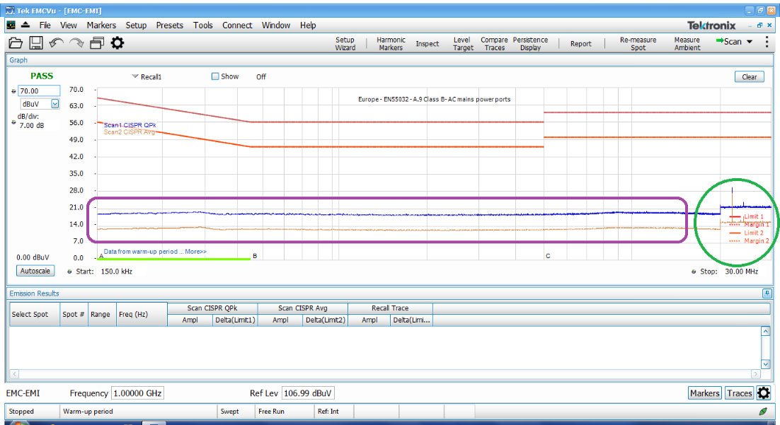

Figure1 (150kHz~30MHz_Former)

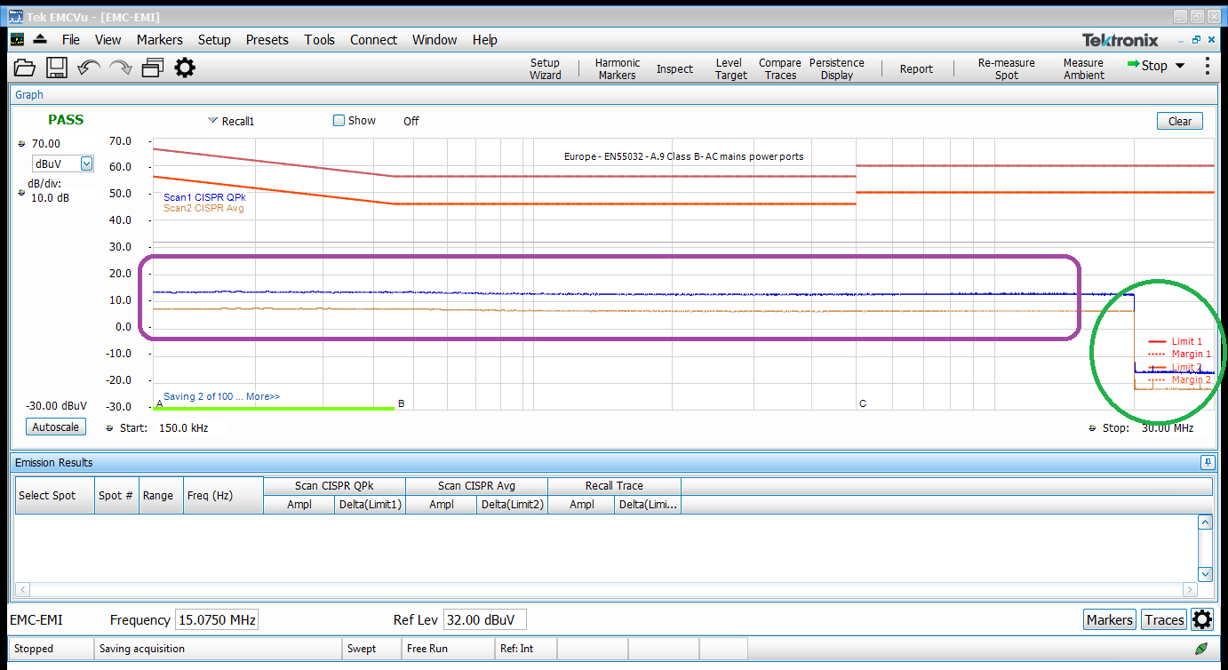

Figure2 (150kHz~30MHz_Later)

1. Under the condition of no input signal and the same test settings, we tested at 150kHz~6.2GHz, the difference between the former and the later of floor noise values is approximately 10dBuV for the frequency range from 200MHz to 6.2GHz. (See the Figure 3 &4)

Figure3 (150kHz~6.2GHz_Former)

Figure4 (150kHz~6.2GHz_Later)

* 1. Used the instrument RSA306B after sending to Dongguan for calibration and Software SignalVu-PC：

1. Under the condition of no input signal and the same test settings, we tested at 150kHz~200MHz in one day, the difference between the former and the later of floor noise values is approximately 9dBuV for the frequency range from 40MHz to 200MHz. (See the Figure 5 &6)

Figure5 (150kHz~200MHz_Data_0715_Former)

Figure6 (150kHz~200MHz_Data_0715_Later)

1. Under the condition of no input signal and the same test settings, we tested at 150kHz~200MHz the next day, the difference between the former and the later of floor noise values is approximately 17dBuV for the frequency range from 150kHz to 300kHz. (See the Figure 7 & 8)

Figure7 (150kHz~200MHz_Data_0715)

Figure8 (150kHz~200MHz_Data_0716)

1. Under the condition of no input signal and the same test settings, we tested at 150kHz~6.2GHz, the difference between the former and the later of floor noise values is also different in initial position. (See the Figure 9 & 10)

Figure9 (150kHz~6.2GHz_Data_0715)

Figure10 (150kHz~6.2GHz_Data_0716)

1. Under the condition of no input signal and the same test settings, we tested at 150kHz~60MHz or higher, the test interface sometimes cannot display the test result when the test is done.
2. Under the condition of no input signal and the same test settings,

we tested at 150kHz~30MHz, 150kHz~40MHz, the test result is 6dBuV. (See the Figure 11 &12)

We tested at 150kHz~50MHz, the test result will drop from 6dBuV to -12dBuV in 5MHz. (See the Figure 13)

We tested at 150kHz~60MHz, the test result will drop from 6dBuV to -12dBuV in 10MHz. (See the Figure 14)

We tested at 150kHz~200MHz, the test result will drop from 6dBuV to -12dBuV in 40MHz. (See the Figure 15)

Figure11 (150kHz~30MHz)

Figure12 (150kHz~40MHz)

Figure13 (150kHz~50MHz)

Figure14 (150kHz~60MHz)

Figure15 (150kHz~200MHz)